# Adding Passive Check Host

For adding private subnet servers to check_mk monitoring tool. We need NAT/Linux server infront of private subnet servers to send data to check_MK host. NAT/Linux server is for port forwarding. No data will be stored in NAT/Linux server.

**Steps to be followed in NAT/Linux server.**

We will be installing nginx and nginx-all-modules in NAT/Linux server.

Step 1: Login to Customer NAT Server (Recommended) / Any server which has Public IP and install Nginx in the NAT server.

**yum install nginx nginx-all-modules**

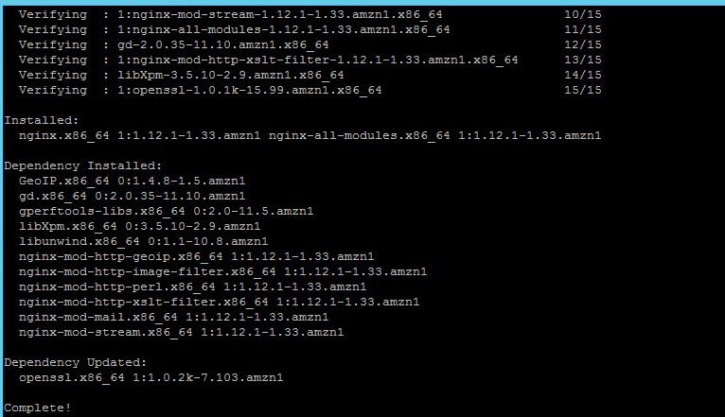

Step 2: Open the **nginx.conf** from **/etc/nginx/** and append the mentioned line in the file.

*Appending Text:* ***include /etc/nginx/tcpconf.d/*;***

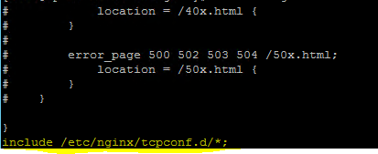

Step 3: Create a **tcpconf.d** directory in the path **/etc/nginx/**

**mkdir -p /etc/nginx/tcpconf.d**



Step 4: Create a config file in the name of **checkmk.conf** and add the below configuration in the config file and edit it.

stream {

server {

listen 6500; #port number to get the request from the Check_MK

#TCP traffic will be proxied to the "stream_backend" upstream group

proxy_pass End_IP:6556; #End server IP

}

}

Step 5: Restart the Nginx twice by using the below command

Command: **Service nginx restart**

Step 6: In Private Server, Install the Check_MK agent as mentioned in the Active check.

### **Windows Client:**

Download the agent from the browser and install the agent.



Add the below rules in network security group of the NAT instance.

Port 6556 is used by Check_MK Server (Server IP).

1. Add ‘**Custom TCP**’ rule: **6556** for Check_MK Server IP
2. Add ‘**ALL ICMP**’ rule: **0-65635** for Check_MK Server IP